Venues Data Analysis of Moscow City

1. Introduction

1.1 Background

Moscow, one of the largest metropolises in the world with a population of more than 12 million people, covers an area of ​​more than 2561.5 km² with an average density of inheritance of 4924.96 people / km² [1](https://ru.wikipedia.org/wiki/%D0%9C%D0%BE%D1%81%D0%BA%D0%B2%D0%B0" \o "https://ru.wikipedia.org/wiki/%D0%9C%D0%BE%D1%81%D0%BA%D0%B2%D0%B0).

Moscow is divided into 12 districts (125 boroughs, 2 urban boroughs, 19 settlement boroughs).

Moscow has a very uneven population density from 30429 people / km² for the "Зябликово" borough, to 560 people / km² for the "Молжаниновский" borough [2](https://ru.wikipedia.org/wiki/%D0%A0%D0%B0%D0%B9%D0%BE%D0%BD%D1%8B_%D0%9C%D0%BE%D1%81%D0%BA%D0%B2%D1%8B" \o "https://ru.wikipedia.org/wiki/%D0%A0%D0%B0%D0%B9%D0%BE%D0%BD%D1%8B_%D0%9C%D0%BE%D1%81%D0%BA%D0%B2%D1%8B).

The average cost of real estate varies from 68,768 rubles / m² for the "Кленовское" borough to 438,568 rubles / m² for the "Арбат" borough [3](https://www.mirkvartir.ru/journal/analytics/2018/02/25/reiting-raionov-moskvi-po-stoimosti-kvartir" \o "https://www.mirkvartir.ru/journal/analytics/2018/02/25/reiting-raionov-moskvi-po-stoimosti-kvartir).

1.2 Business Problem

Owners of cafes, fitness centers and other social facilities are expected to prefer boroughs with a high population density. Investors will prefer areas with low housing costs and low competitiveness.

On the part of residents, the preference is expected for a boroughs with a low cost of housing and good accessibility of social places.

In my research, I will try to determine the optimal places for the location of fitness centers in Moscow boroughs, taking into account the number of people, the cost of real estate and the density of other fitness facilities.

The key criteria for selecting suitable locations for fitness centers will be:

* High population of the borough
* Low cost of real estate in the area
* The absence in the immediate vicinity of other fitness facilities of a similar profile

I will use the approaches and methods of machine learning to determine the location of fitness centers in accordance with the specified criteria.

The main stakeholders of my research will be investors interested in opening new fitness centers.

2. Data acquisition and cleaning

2.2. Data requirements

Based on the problem and the established selection criteria, to conduct the research, I will need the following information:

1. main dataset with the list of Moscow Borough, containing the following attributes:
   * name of the each Moscow Borough
   * type of the each Moscow Borough
   * name of the each Moscow District in which Borough is belong to
   * area of the each Moscow Borough in square kilometers
   * the population of the each Moscow Borough
   * housing area of the each Moscow Borough in square meters
   * average housing price of the each Moscow Borough
2. geographical coordinates of the each Moscow Borough
3. shape of the each Moscow Borough in GEOJSON format
4. list of venues placed in the each Moscow Borough with their geographical coordinates and categories

2.3. Describe data sources

**2.3.1. Moscow Boroughs dataset**

Data for Moscow Boroughs dataset were downloaded from multiple HTTP page combined into one pandas dataframe.

* List of Moscow District and they Boroughs were downloaded from the page [Moscow Boroughs](https://gis-lab.info/qa/moscow-atd.html" \o "https://gis-lab.info/qa/moscow-atd.html)
* Information about area of the each Moscow Borough in square kilometers, their population and housing area in square meters were downloaded from the page [Moscow Boroughs Population Density](https://ru.wikipedia.org/wiki/%D0%A1%D0%BF%D0%B8%D1%81%D0%BE%D0%BA_%D1%80%D0%B0%D0%B9%D0%BE%D0%BD%D0%BE%D0%B2_%D0%B8_%D0%BF%D0%BE%D1%81%D0%B5%D0%BB%D0%B5%D0%BD%D0%B8%D0%B9_%D0%9C%D0%BE%D1%81%D0%BA%D0%B2%D1%8B" \o "https://ru.wikipedia.org/wiki/%D0%A1%D0%BF%D0%B8%D1%81%D0%BE%D0%BA_%D1%80%D0%B0%D0%B9%D0%BE%D0%BD%D0%BE%D0%B2_%D0%B8_%D0%BF%D0%BE%D1%81%D0%B5%D0%BB%D0%B5%D0%BD%D0%B8%D0%B9_%D0%9C%D0%BE%D1%81%D0%BA%D0%B2%D1%8B)
* Information about housing price of the each Moscow Borough were downloaded from the page [Moscow Boroughs Housing Price](https://www.mirkvartir.ru/journal/analytics/2018/02/25/reiting-raionov-moskvi-po-stoimosti-kvartir" \o "https://www.mirkvartir.ru/journal/analytics/2018/02/25/reiting-raionov-moskvi-po-stoimosti-kvartir)

A special Python function has been developed for HTML table parse. This function help me:

* to find number of rows and columns in a HTML table
* to get columns titles, if possible
* to convert string to float, if possible
* return result in form of the Pandas dataframe

**2.3.2. Moscow Boroughs geographical coordinates**

Geographical coordinates of the each Moscow Borough were queried through Nominatim service. As the Nominatim service are quite unstable it was quite a challenge to request coordinate in several iterations.

**2.3.3. Moscow Boroughs shape in GEOJSON format**

Shape of the each Moscow Borough in GEOJSON format was downloaded from the page [Moscow Boroughs GEOJSON](http://gis-lab.info/data/mos-adm/mo.geojson" \o "http://gis-lab.info/data/mos-adm/mo.geojson)

**2.3.4. Moscow Boroughs venues**

To determine **venues** the service **Forsquare API** was used.  
The API of **Forsquare** service have the restriction of 100 **venues**, which it can return in one request.  
To obtain list of all **venues** I used the following approach:

* present Moscow area in the form of a regular grid of circles of quite small diameter, no more than 100 **venues** in each circle
* perform exploration using **Forsquare API** with quite bigger radius than circle of a grid to make sure it overlaps/full coverage to don't miss any venues
* cleaning list of venues from duplicates.

This approach and some of the Python code was taken from the work presented here. [https://cocl.us/coursera_capstone_notebook](https://cocl.us/coursera_capstone_notebook" \o "https://cocl.us/coursera_capstone_notebook)

Circle of 28 000 meter in radius cover all Moscow Boroughs.  
In my research grid of circles contains 7899 cells with radius 300 meter.  
Foursquare API have a certain limitation for API call in one day to explore venues.  
In my case it was about 2000 calls per day.  
So in addition I have to divide grid dataset into subset and call Foursquare API for several days.

2.4. Describe data cleansing

**2.4.1. Moscow Boroughs dataset cleansing**

As data for Moscow Boroughs dataset were downloaded from multiple HTTP page it was necessary to perform a data cleaning. Such as:

* remove some unused colums
* strip text columns from additional information like ' \n\t'
* replace some Borough_Name as of russian letters "е" and "ё"
* change places of some words in Borough_Name
* clear Borough Name from additional information, such as ', поселение ', ', городской округ '
* replace '\n', ' ↗' and '↘' in some columns
* delete extra spaces in numeric columns
* replace ',' to '.' for float columns
* convert from float to int for integer columns
* convert from string to float for numeric columns

As the result I, had a dataset with all 146 Moscow Boroughs. Result dataset contains columns:

* **Borough_Name** - name of the Moscow Borough - is a unique key of the dataset
* **District_Name** - name of the Moscow District in which Borough is belong to
* **Borough_Type** - type of the Moscow Borough
* **OKATO_Borough_Code** - numeric code of the Moscow Borough
* **OKTMO_District_Code** - numeric code of the Moscow District
* **Borough_Area** - area of the Moscow Borough in square kilometers
* **Borough_Population** - population of the Moscow Borough
* **Borough_Population_Density** - population density of the Moscow Borough
* **Borough_Housing_Area** - housing area of the Moscow Borough in square meters
* **Borough_Housing_Area_Per_Person** - housing area per person of the Moscow Borough in square meters
* **Borough_Housing_Price** - average housing price of the Moscow Borough

I had a problem to found proper statistics about “housing prices” and “housing area” for some Moscow boroughs, so I had to exclude 26 boroughs from my analysis. Fortunately, they all had a low population density, which meat criteria of my research and did not reduce it quality.

**2.4.2. Moscow Boroughs geographical coordinates cleansing**

Nominatim service not only quite unstable.  
It also have an occasionally problem with russian leter **ё**. So I have to manyaly obtain coordinates for such boroughs as:

* Дес**ё**новское, Поселение, Новомосковский
* Сав**ё**лки, Муниципальный округ, ЗелАО
* Кл**ё**новское, Поселение, Троицкий
* And some others.

Another problem with Nominatim service is that it return not very accurate coordinate of some Boroughs.  
So I needed to adjust they manually in the map.

As the result I, had a dataset with all 146 Moscow Boroughs geographical coordinates:

* **Borough_Name** - name of the Moscow Borough
* **Latitude** - geographical Latitude of the Moscow Borough
* **Longitude** - geographical Longitude of the Moscow Borough

**2.4.3. Moscow Boroughs shape in GEOJSON format cleansing**

GEOJSON file downloaded from the page [Moscow Boroughs GEOJSON](http://gis-lab.info/data/mos-adm/mo.geojson) was quite good and not required any addition clearing.

**2.4.4. Moscow Boroughs venues cleansing**

Using **Forsquare API** I obtained 34460 venues in 7899 cells.  
As I used a quite bigger radius (350 meters) for venue explorations than circle of a grid (300 meters), there was a need to remove duplicates venues.  
After duplicates removal I had 27622 unique venues in the circle radius of 28 000 meters around the Moscow City.

The second task was to bind each venue to Moscow Boroughs in which borders they were placed.  
To perform this task I created a polygon for each Moscow Borough from GEOJSON file and found which venues coordinate included into each polygon.

The third task was to remove all the venues that placed outside of the Moscow boroughs.

The fourth task was to get main category from the category list for each venue.

As the result, I had list of 20864 venues placed in the Moscow Boroughs with their geographical coordinates and categories

2.5. Example of the resulting datasets

**2.5.1. The result Moscow Boroughs dataset**

The prepared and cleared Moscow Boroughs dataset can be downloaded by link [Moscow Boroughs dataset](https://raw.githubusercontent.com/romapres2010/Coursera_Capstone/master/data/Moscow_Borough_df.csv)

The picture below shows a small part of the Moscow Boroughs dataset

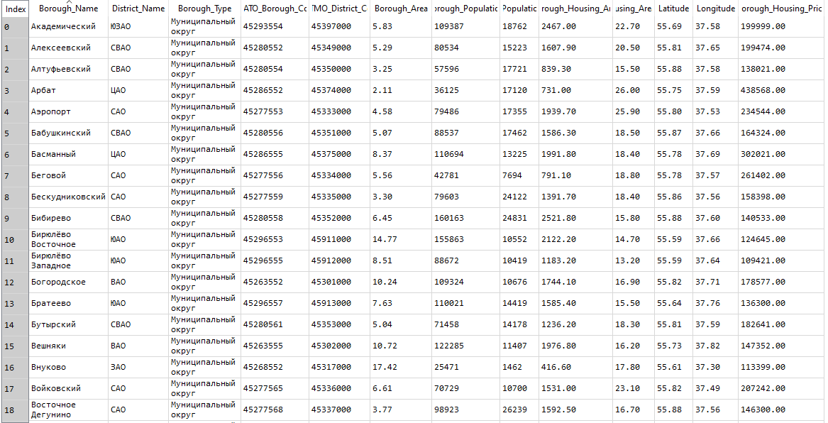

**2.5.2. Boroughs population in Moscow City map**

The picture below shows a choropleth map of the Moscow Boroughs population and the center of each boroughs.  
As we can see, use center of the boroughs for searching venues is quite useless as each borough have very sophisticated shape.  
So I needed to present Moscow area in the form of a regular grid of circles of quite small diameter inside the circle of 28 000 meter in radius, which cover all the Moscow Boroughs in my research.

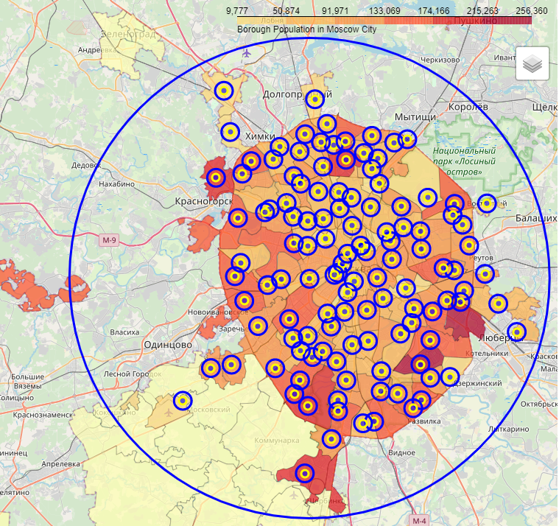

The picture below shows an Example of such hexagonal grid of area candidates

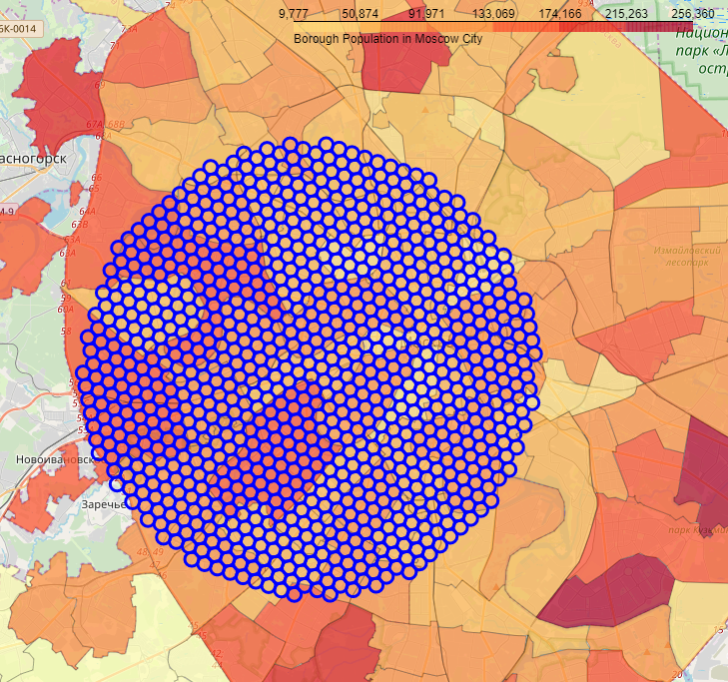

**2.5.3. The result Moscow venues dataset**

The prepared and cleared Moscow venues dataset can be downloaded by link [Moscow venues dataset](https://raw.githubusercontent.com/romapres2010/Coursera_Capstone/master/data/Moscow_venues_df.csv)

The picture below shows a small part of the Moscow Boroughs dataset

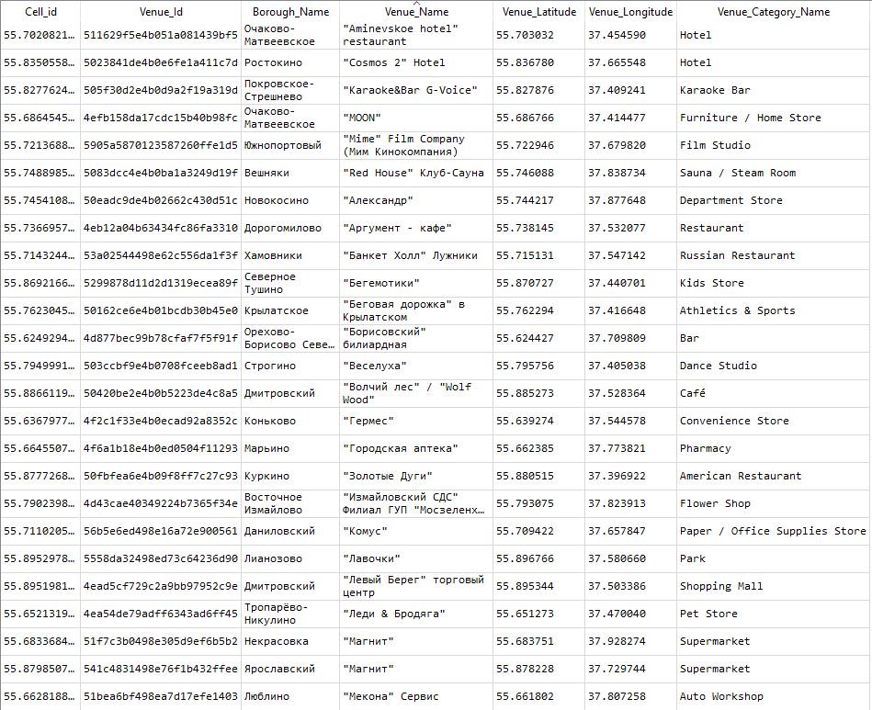

The picture below shows a example of the some Moscow Boroughs and their venues

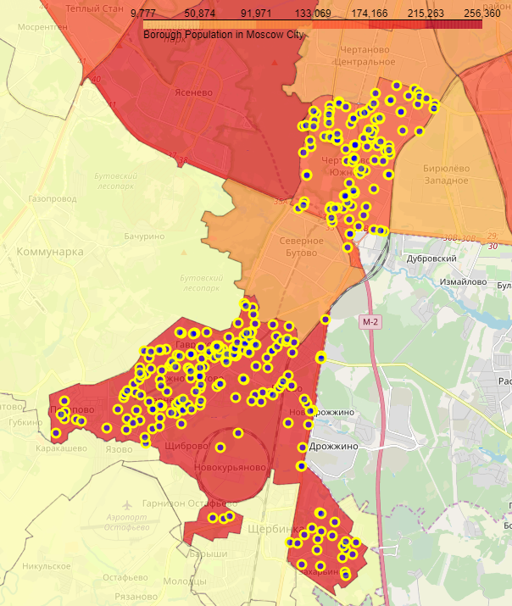

Exploratory Data Analysis

The key criteria for my research are:

* high population of the borough
* low cost of real estate in the area

We have theese key features in Moscow Boroughs dataset:

* District - name of the Moscow District in which Borough is belong to
* Area - area of the Moscow Borough in square kilometers
* Population_Density - population density of the Moscow Borough
* Housing_Area - housing area of the Moscow Borough in square meters

Let's analyze features and key criteria using:

* descriptive statistical analysis
* categorical variables analysis
* сorrelation analysis

Descriptive statistical analysis

The picture below shows basic statistics for all features.  
As we can see, Moscow Boroughs has a very uneven population from 12 194 people to 253 943 people.  
The average cost of real estate varies from 109 421 rubles/m² to 438 568 rubles/m².

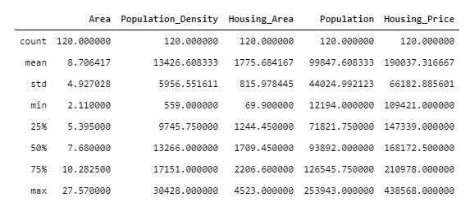

Categorical variables analysis

I have one categorical variable - name of the Moscow District in which Borough is belong to.  
Let's analize relationship between categorical feature 'District' and key criteria using boxplots visualization.

The picture below shows relationship between 'District' and 'Population'.  
We can see that the distributions of Population between Boroughs in the different Districts have aт overlap, but we can estimate, that the most populated Boroughs are placed in 'ЮЗАО', 'ЮАО', 'СЗАО' and 'ЗАО' Districts.

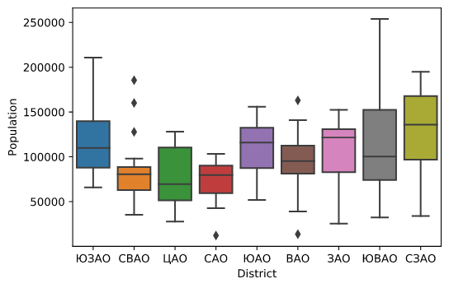

The next picture shows relationship between 'District' and 'Housing Price'.  
We can see that the distributions of Housing Price between Boroughs in the different Districts are distinct enough.  
As the result of boxplots visualization, categorical feature 'District' would be a good potential redictor only of Housing Price.

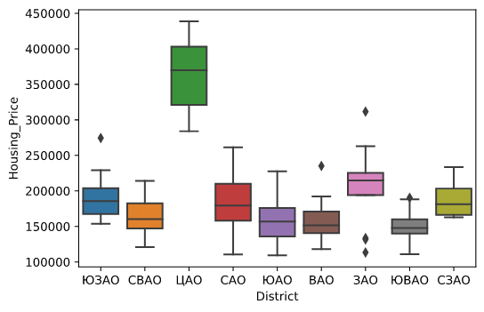

Correlation analysis

The picture below shows correlation matrix.  
Correlation between 'Area', 'Population_Density' and 'Population' is statistically significant, although the linear relationship isn't extremely strong.  
Correlation between 'Housing_Are' and 'Population' is statistically hughly significant, and the linear relationship is extremely strong.  
Correlation between 'Area', 'Population_Density', 'Housing_Area' and 'Housing_Price' is not statistically significant, although the linear relationship isn't strong.  
Correlation between 'Area' to 'Population_Density' is statistically hughly significant, and the linear relationship is extremely strong.  
So we can exclude 'Population_Density' from our considerations.

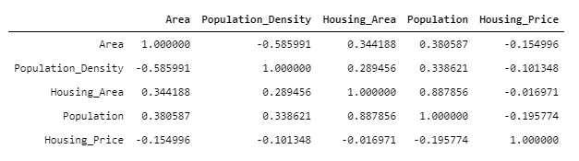

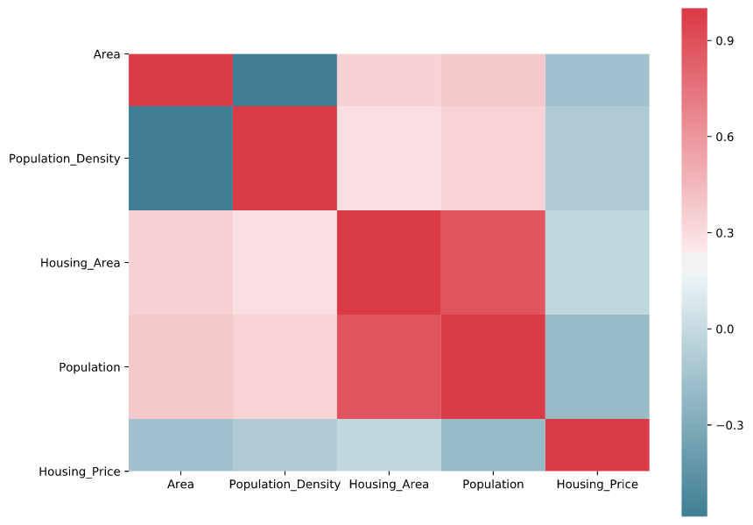

Clustering

In my research, I decided to perform Moscow Boroughs segmentation with K-Means to detect Boroughs that have highest population and smallest housing price.

K-Means Clustering with elbow method

To determine right number of clusters, I used elbow method. According elbow method I implemented K-Means clustering from 1 to 10 centroids and calculate distortion and inertia for each variant.

The next pictures show elbow method using Distortion and Inertia. We can see that there are elbows at 3 and 5 centroid.  
I decided to use 3 centroid In my research.

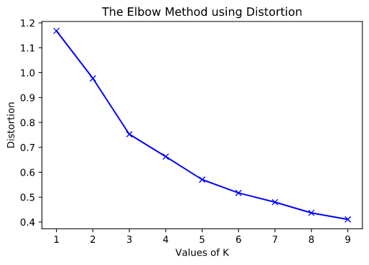

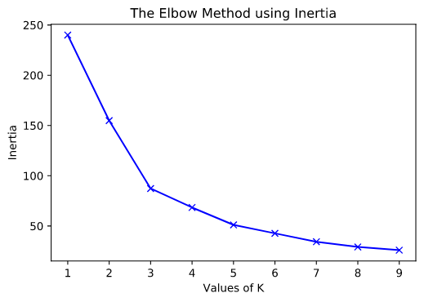

Analyze K-Means clusters

To analyze K-Means clusters I calculated some statistics:

* count boroughs in the cluster
* sum population in the cluster
* sum area of the cluster
* mean population in the boroughs in the cluster
* mean housing price in the boroughs in the cluster
* % population in the cluster to all Moscow City population
* % area of the cluster to all Moscow City area
* population density in the cluster

The next pictures show these statistics

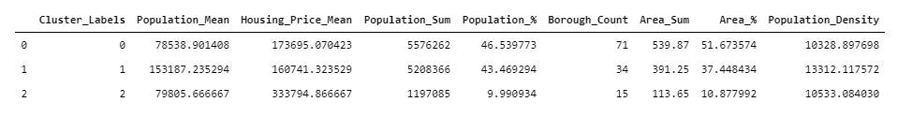

As we can see, there are 3 clusters

* "0" Cluster - characterized by low mean population (78538 people per Borough), relatively high mean housing price (173695 rubles/m²) and low population density (10328 people/km²)
* "1" Cluster - characterized by highest mean population (153187 people per Borough), smallest mean housing price (160741 rubles/m²) and highest population density (13312 people/km²)
* "2" Cluster - characterized by low mean population (79805 people per Borough), highest mean housing price (333794 rubles/m²) and low population density (10533 people/km²)

The next pictures show these clusters using boxplots visualization.

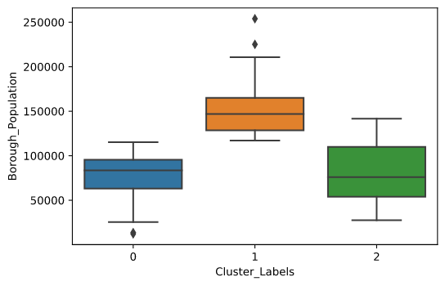

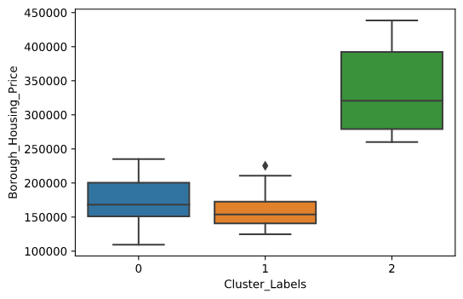

Very good result of the KMean clustering.

"1" Cluster perfectly fits my research criteria:

* boroughs from this cluster have highest mean population and smallest mean housing price
* in 34 boroughs about 43% of the Moscow population occupied only 37% of the Moscow City area, that mean the highest population density

Vizualize clusters on choropleth map

The next picture shows clusters on choropleth map.

